Title of Report


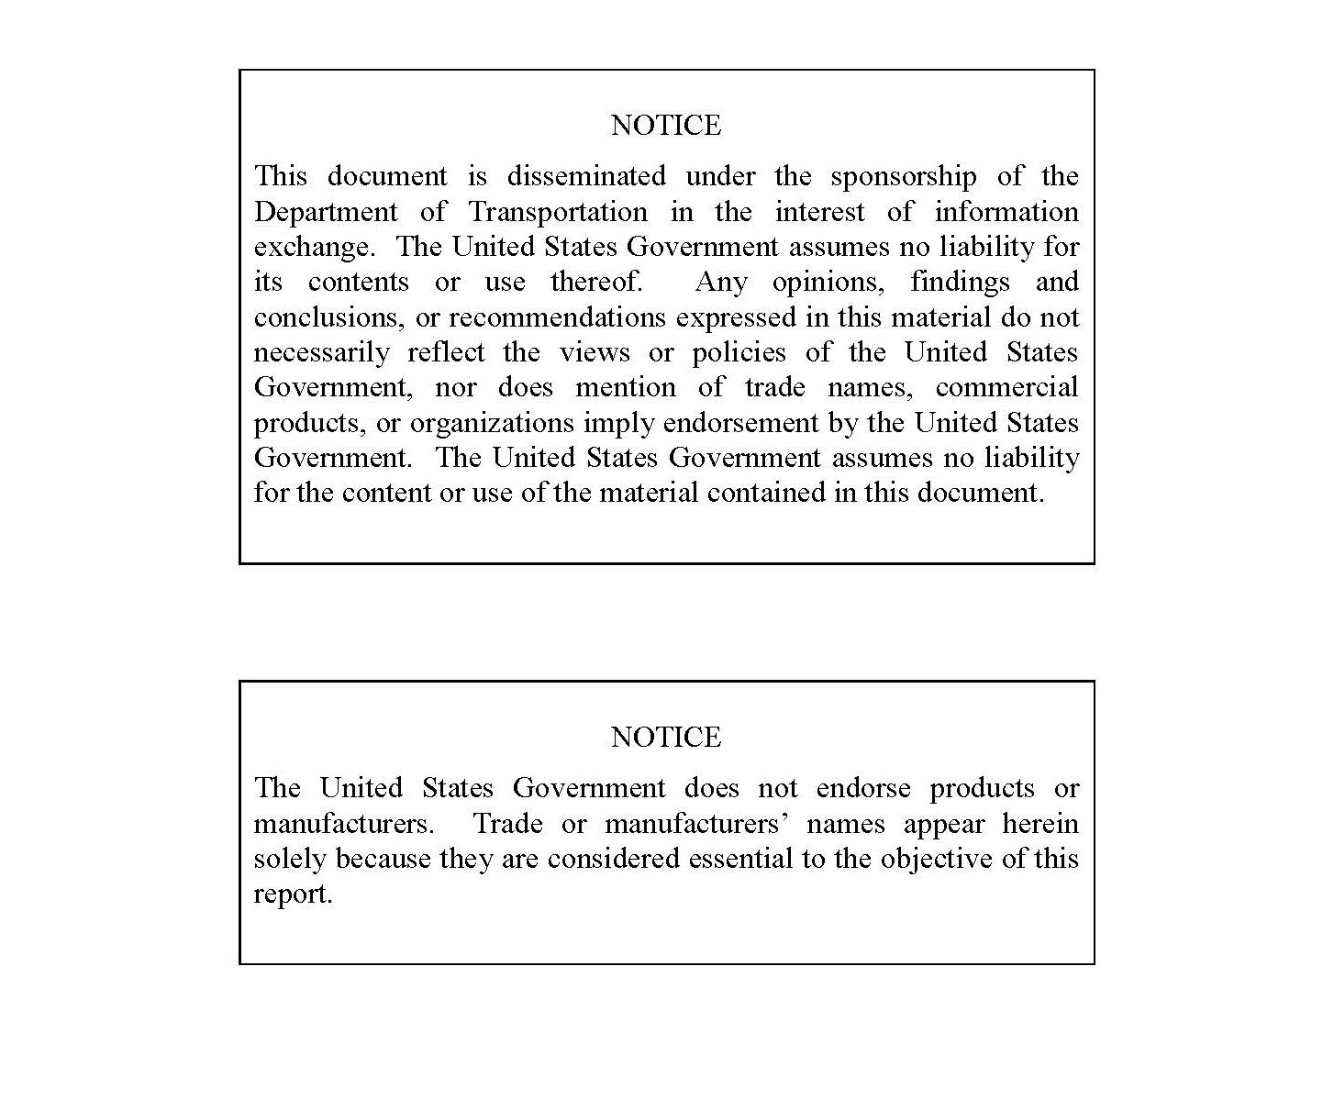

REPORT DOCUMENTATION PAGE |  |  |  |  |  |  |  |  | Form Approved OMB No. 0704-0188
The public reporting burden for this collection of information is estimated to average 1 hour per response, including the time for reviewing instructions, searching existing data sources, gathering and maintaining the data needed, and completing and reviewing the collection of information. Send comments regarding this burden estimate or any other aspect of this collection of information, including suggestions for reducing the burden, to Department of Defense, Washington Headquarters Services, Directorate for Information Operations and Reports (0704-0188), 1215 Jefferson Davis Highway, Suite 1204, Arlington, VA 22202-4302. Respondents should be aware that notwithstanding any other provision of law, no person shall be subject to any penalty for failing to comply with a collection of information if it does not display a currently valid OMB control number.
PLEASE DO NOT RETURN YOUR FORM TO THE ABOVE ADDRESS.
1. REPORT DATE (DD-MM-YYYY) |  |  | 2. REPORT TYPE  Technical Report |  |  |  |  |  | 3. DATES COVERED (From - To)
4. TITLE AND SUBTITLE |  |  |  |  |  |  | 5a. CONTRACT NUMBER
 |  |  |  |  |  |  | 5b. GRANT NUMBER
 |  |  |  |  |  |  | 5c. PROGRAM ELEMENT NUMBER
6. AUTHOR(S) |  |  |  |  |  |  | 5d. PROJECT NUMBER
 |  |  |  |  |  |  | 5e. TASK NUMBER
 |  |  |  |  |  |  | 5f. WORK UNIT NUMBER
7. PERFORMING ORGANIZATION NAME(S) AND ADDRESS(ES)  Name of Organization  Street Address  City/State Zip Code |  |  |  |  |  |  |  | 8. PERFORMING ORGANIZATION REPORT NUMBER
9. SPONSORING/MONITORING AGENCY NAME(S) AND ADDRESS(ES)  U.S. Department of Transportation  Federal Railroad Administration  Office of Railroad Policy and Development  Office of Research, Development and Technology  Washington, DC 20590 |  |  |  |  |  |  |  | 10. SPONSOR/MONITOR'S ACRONYM(S)
 |  |  |  |  |  |  |  | 11. SPONSOR/MONITOR'S REPORT NUMBER(S)
12. DISTRIBUTION/AVAILABILITY STATEMENT
This document is available to the public through the FRA website.
13. SUPPLEMENTARY NOTES
COR:
14. ABSTRACT
15. SUBJECT TERMS
16. SECURITY CLASSIFICATION OF: |  |  |  | 17. LIMITATION OF ABSTRACT | 18. NUMBER OF PAGES | 19a. NAME OF RESPONSIBLE PERSON
a. REPORT | b. ABSTRACT | c. THIS PAGE
 |  |  |  |  |  | 19b. TELEPHONE NUMBER (Include area code)
Standard Form 298 (Rev. 8/98)
Prescribed by ANSI Std. Z39.18

METRIC/ENGLISH CONVERSION FACTORS

ENGLISH TO METRIC |  |  |  |  | METRIC TO ENGLISH
LENGTH (APPROXIMATE) |  |  |  |  | LENGTH (APPROXIMATE)
1 inch (in) | = | 2.5 centimeters (cm) |  | 1 millimeter (mm) |  | = |  |  | 0.04 inch (in)
1 foot (ft) | = | 30 centimeters (cm) |  | 1 centimeter (cm) |  | = |  |  | 0.4 inch (in)
1 yard (yd) | = | 0.9 meter (m) |  | 1 meter (m) |  | = |  |  | 3.3 feet (ft)
1 mile (mi) | = | 1.6 kilometers (km) |  | 1 meter (m) |  | = |  |  | 1.1 yards (yd)
 |  |  |  | 1 kilometer (km) |  | = |  |  | 0.6 mile (mi)
AREA (APPROXIMATE) |  |  |  |  | AREA (APPROXIMATE)
1 square inch (sq in, in²) | = | 6.5 square centimeters (cm²) |  | 1 square centimeter (cm²) |  | = |  |  | 0.16 square inch (sq in, in²)
1 square foot (sq ft, ft²) | = | 0.09 square meter (m²) |  | 1 square meter (m²) |  | = |  |  | 1.2 square yards (sq yd, yd²)
1 square yard (sq yd, yd²) | = | 0.8 square meter (m²) |  | 1 square kilometer (km²) |  | = |  |  | 0.4 square mile (sq mi, mi²)
1 square mile (sq mi, mi²) | = | 2.6 square kilometers (km²) |  | 10,000 square meters (m²) |  | = |  |  | 1 hectare (ha) = 2.5 acres
1 acre = 0.4 hectare (he) | = | 4,000 square meters (m²)
MASS - WEIGHT (APPROXIMATE) |  |  |  |  | MASS - WEIGHT (APPROXIMATE)
1 ounce (oz) | = | 28 grams (gm) |  | 1 gram (gm) |  | = |  | 0.036 ounce (oz)
1 pound (lb) | = | 0.45 kilogram (kg) |  | 1 kilogram (kg) |  | = |  | 2.2 pounds (lb)
1 short ton = 2,000 pounds (lb) | = | 0.9 tonne (t) |  | 1 tonne (t) |  | =  = |  | 1,000 kilograms (kg)  1.1 short tons
VOLUME (APPROXIMATE) |  |  |  |  | VOLUME (APPROXIMATE)
1 teaspoon (tsp) | = | 5 milliliters (ml) |  |  | 1 milliliter (ml) |  | = |  |  | 0.03 fluid ounce (fl oz)
1 tablespoon (tbsp) | = | 15 milliliters (ml) |  |  | 1 liter (l) |  | = |  |  | 2.1 pints (pt)
1 fluid ounce (fl oz) | = | 30 milliliters (ml) |  |  | 1 liter (l) |  | = |  |  | 1.06 quarts (qt)
1 cup (c) | = | 0.24 liter (l) |  |  | 1 liter (l) |  | = |  |  | 0.26 gallon (gal)
1 pint (pt) | = | 0.47 liter (l)
1 quart (qt) | = | 0.96 liter (l)
1 gallon (gal) | = | 3.8 liters (l)
1 cubic foot (cu ft, ft³) | = | 0.03 cubic meter (m³) |  |  | 1 cubic meter (m³) |  | = |  |  | 36 cubic feet (cu ft, ft³)
1 cubic yard (cu yd, yd³) | = | 0.76 cubic meter (m³) |  |  | 1 cubic meter (m³) |  | = |  |  | 1.3 cubic yards (cu yd, yd³)
TEMPERATURE (EXACT) |  |  |  |  | TEMPERATURE (EXACT)
[(x-32)(5/9)] °F |  | = | y °C |  | [(9/5) y + 32] °C |  | = |  | x °F
For more exact and or other conversion factors, see NIST Miscellaneous Publication 286, Units of Weights and Measures. Price $2.50 SD Catalog No. C13 10286 Updated 6/17/98

Acknowledgements [Optional]
Note: FRA staff should not be acknowledged for providing funding. If appropriate, they can be acknowledged for technical contributions.

Contents
Executive Summary 1
1. Introduction 2
1.1 Background 2
1.2 Objectives 2
1.3 Overall Approach 2
1.4 Scope 2
1.5 Organization of the Report 2
2. Section 2 Title 3
2.1 Subsection 1 3
2.2 Subsection 2 3
3. Conclusion 5
4. References 6
Appendix A. Appendix Heading (Optional) 7
Abbreviations and Acronyms 8

Illustrations
Figure 1. [ENTER CAPTION] 2

Tables
Table 1. [ENTER CAPTION] 3

Executive Summary
Enter Text [Maximum 1,000 words; approximately 1–1 ½ pages]

(Refer to Guidelines for Writing Technical Reports.)

Introduction
Text [Introductory Paragraph]

Background
Text

Figure 1. [ENTER CAPTION]

Objectives
Text

Overall Approach
Text

Scope
Text

Organization of the Report
Text

Section 2 Title
Text [Introductory Paragraph]

Subsection 1
Text
Table 1. [ENTER CAPTION]
Header 1 | Header 2 | Header 3 | Header 4
Row 1
Row 2
Row 3
Row 4
Row 5

Subsection 2
Text
Sample footnote reference.

Subheading 1
Text
Reference in text sample. (Author, Year)
Reference in text sample. (Author, Year)
Reference in text sample. (Author, Year)
Reference in text sample. (Author, Year)

Subheading 2
Text

Subheading 3
Text

Subheading 4
Text

Subheading 5
Text

Conclusion
Maximum 500 words; approximately 1 page

References
Author. (Year). Book Title. In B. Author, Book Title (p. Pages). City: Publisher.
Author. (Year). Conference Title. Conference Publication Name (p. Pages). City: Publisher.
Author. (Year). Journal Title. Journal Name, Pages.
Author. (Year, Month Day). Name of Web Page. Retrieved from Name of Web Site: URL

Appendix A.
Appendix Heading (Optional)
[Add information related to the Appendix. Insert file text here.]

Abbreviations and Acronyms
ACRONYMS | EXPLANATION
AAA | List in alphabetical order
BBB | List in alphabetical order
CCC | List in alphabetical order
DDD | List in alphabetical order
EEE | List in alphabetical order
FFF | List in alphabetical order

[sample foot note reference]

