New York Penn Station Service Optimization
Study

  - Phase I Report - Addendum | July 2026

1 Introduction
The United States Department of Transportation (USDOT), Federal Railroad Administration (FRA), and Amtrak are advancing a multi-pronged strategy to reimagine and modernize New York Penn Station (Penn Station or the Station) through a project known as Penn Transformation (or Project). In May 2026, following a competitive procurement process, Amtrak selected Penn Transformation Partners (PTP) as the Master Developer for the Penn Transformation Project, which PTP will lead in collaboration with Amtrak and with funding support from the FRA.
In parallel with early development of Penn Transformation and Amtrak’s procurement of a Master Developer, FRA initiated the Penn Station Service Optimization Study (the Study) in October 2025. The first of two Study phases was completed in June 2026. The Phase I schedule was coordinated with Amtrak’s Master Developer procurement process to ensure future plans for improvements to Penn Station’s track and platform level were available to inform the Master Developer’s design for Penn Transformation. Therefore, Phase I focused on identifying service options and proposed infrastructure improvements within the existing track and platform configuration of the complex, which will require additional, currently unfunded, capital investments. FRA will initiate Phase II of the Study in July 2026. Phase II will establish a vision for Penn Station service that identifies capital projects and operational changes in the broader New York Metropolitan area that enable future service growth.
The Phase I infrastructure improvement results, documented in the Phase I Service Optimization Study Report - June 2026 (Phase I Report), are either intended to be implemented by Amtrak and relevant partners as part of, or in conjunction with, Penn Transformation — or critically, must not be precluded by the Project. These results include approximate locations of new Vertical Circulation Elements (VCEs)— stairs and escalators—within the existing station complex, changes to track and platform configurations, and not-to-preclude elements that may be constructed in the future.
The Phase I Study’s outputs are consistent with Penn Transformation’s project goals, which include:
- Renovating and modernizing the station
- Increasing concourse capacity and access
- Enabling safer and more efficient operations
- Accommodating passenger service growth
- Delivering a world-class experience for users
Following Amtrak’s selection of PTP as the Master Developer in June 2026, this Addendum to the Phase I Report acknowledges the need for PTP to build upon the Phase I findings through additional evaluation and refinement. This work will support the continued development of Penn Transformation and help advance toward the goal of entering into construction by the end of 2027.

2 Penn Transformation Partners Proposal
The selected PTP proposal offers a single-level concourse that will feature amenities, bars and restaurants, shops and customer services. The concourse design will be compliant with the Americans with Disabilities Act (ADA). Specific project elements noted in the proposal include:
- Constructing a grand entrance on Eighth Avenue to a new train hall
- Replacing cramped, decrepit walkways with open, beautiful concourses
- Improving platform access and circulation through additional VCEs, removal of some columns and platform appurtenances and more intuitive wayfinding
- Enabling new retail, better wayfinding, and other passenger experience improvements, all while maintaining the iconic Madison Square Garden with a new cladding for a classic look, and
- Improving the station’s existing subterranean structure
Publicly available images provided by PTP are shown below.
Figure 1: Proposed Exterior Image of Penn Station
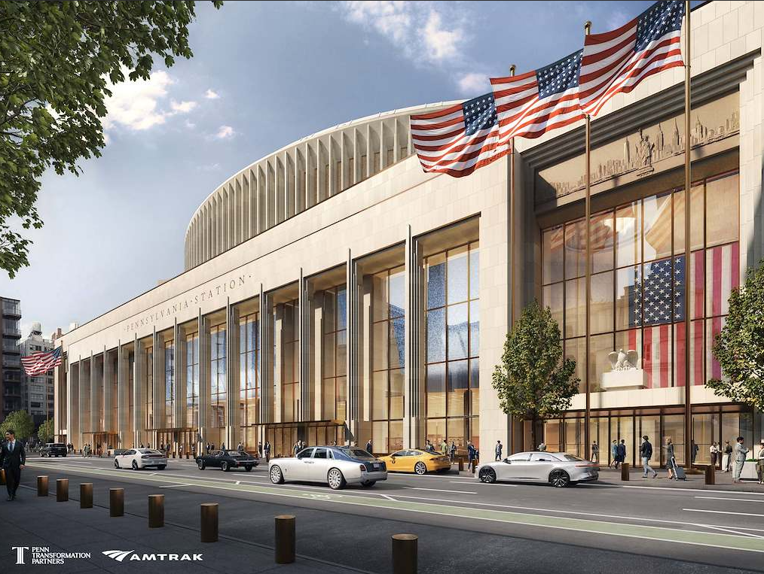
Figure 2: Proposed Concourse Image of Penn Station
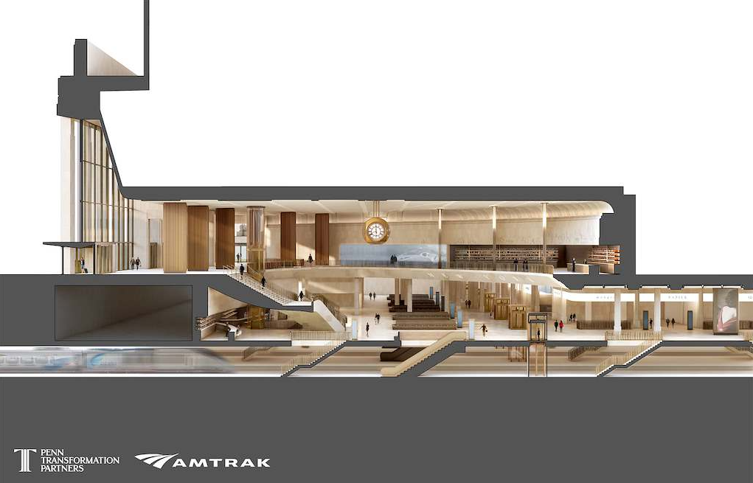

Figure 3: Proposed Platform Level Image of Penn Station
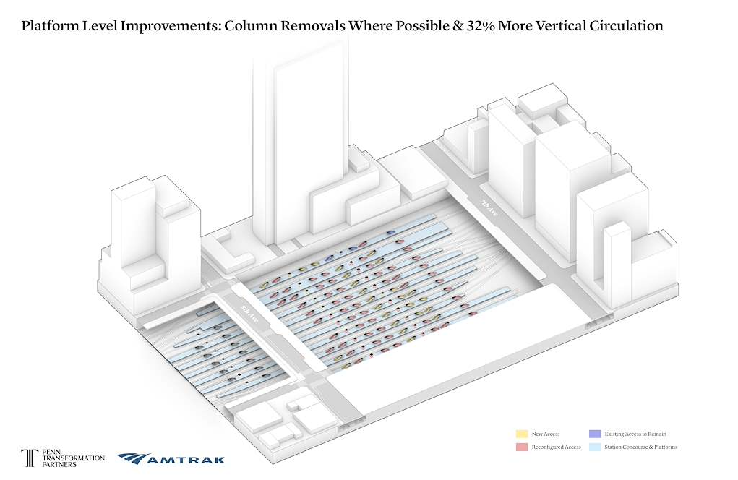

3 Penn Transformation Partners Engagement
As noted throughout the Phase I Report, close coordination among the FRA, Amtrak, and the selected Master Developer is essential to advancing the infrastructure improvements that USDOT expects to be incorporated into Penn Transformation or delivered by Amtrak in conjunction with the Project. Such coordination is critical to completing the project design and achieving the goal of advancing into construction by the end of 2027.
To support this effort, and at Amtrak’s request, the FRA Study Team briefed the three shortlisted proposers in Amtrak’s competitive Master Developer procurement process on the results of the Phase I Study on March 26, 2026. Following Amtrak’s selection of PTP as the Master Developer, FRA, Amtrak, and PTP began close coordination in June 2026 to review the Phase I Study analyses and results, assess PTP’s proposal, and evaluate additional improvement concepts.
The FRA Study Team will continue to engage with PTP over the coming months as PTP further refines its proposal, finalizes the design and placement of VCEs, and evaluates additional improvement concepts. This ongoing work will include assessing the constructability, cost, schedule implications, and operational impacts of proposed track and platform improvements, as well as other strategies intended to achieve the objectives of both the Service Optimization Study and Penn Transformation.
As the Penn Transformation design progresses, PTP will also coordinate closely with NJ Transit and the Metropolitan Transportation Authority, including the Long Island Rail Road and Metro-North Railroad, to ensure that the proposed improvements support the needs of all Penn Station stakeholders and operators.
Concurrently, as described in the Phase I Report, the FRA Study Team will continue engagement with PTP, Amtrak, NJ Transit, and the Metropolitan Transportation Authority during Phase II of the Study.

4 Penn Transformation Partners Additional Improvement Concepts
As part of advancing the results identified in the Phase I Study, PTP will evaluate additional improvement concepts to increase station capacity, including a concept to extend Platforms 1 and 2 (Platform Tracks 1–4) eastward beneath the 7th Avenue Subway (1/2/3 lines) and terminating within the sub-basement of the Penn 11 building, as described below.
This concept was not advanced in Phase I; however, PTP believes the concept may achieve the operational benefits identified in the Phase I Study and merits further exploration. While the SOS Phase I Report concluded with a recommendation of westward platform extensions within the existing footprint, FRA agrees that the evolving context of Penn Transformation allows for consideration of an eastward extension, along with other complementary improvements, that may offer reduced disruption to station operations, improved long-term flexibility, and comparable—or potentially greater—operational benefits.
Eastward Extension Concept Overview
PTP’s eastward extension concept would extend Platforms 1 and 2 up to 450 feet to the east, beneath 7th Avenue and into the footprint of Penn 11.
In coordination with Amtrak, FRA, and the railroad partners, PTP’s continued evaluation of complementary and alternative infrastructure concepts will focus on:
- Advancing engineering design and feasibility analyses.
- Evaluating the capital cost and schedule implications of the eastward extension alternative relative to the westward extension concept, including construction phasing strategies and the impacts of required track outages on station operations.
- Integrating proposed infrastructure improvements with Penn Transformation’s concourse design.
- Refining the design and placement of VCEs necessary to support an eastward or westward extension.
- Developing a stakeholder coordination framework to facilitate ongoing collaboration among project partners and railroad operators.
PTP, FRA, and Amtrak will continue coordinating regarding PTP’s evaluation of the eastward extension to determine whether PTP and Amtrak will incorporate the concept into Penn Transformation.
Aside from potential platform extensions, PTP may also evaluate station operational improvement concepts, which may include train management systems, train ready to start systems, and passenger distribution strategies between Penn Station and Moynihan Train Hall. These concepts may result in further increases in train capacity.

5 Next Steps
Chapter 6 of the Phase I Study report describes the next steps the FRA Study Team will undertake in Phase II of the Study. Concurrently with the Phase II Study, PTP will evaluate the additional improvement concepts as described in Chapter 4 of this Addendum, as well as continue to refine and iterate station design concepts. FRA, PTP, and Amtrak will continue to engage NJ Transit and the Metropolitan Transportation Authority in these efforts.

New York Penn Station Transformation: Modernizing the Complex into a World-Class Facility & Landmark

